# **SPICE Model for a Simple Photo-sensor Circuit**

# Discussion Overview

Breadboarding simple circuits (like our photo-sensor circuit) and testing them are easy and not too costly; however, breadboarding larger and more complex circuits becomes costlier and time consuming. In order to have a good level of confidence in the integrity of a circuit before it is committed to manufacturing, schematics and simulation programs are used to test out the design.

Today, we will learn about one of these schematic capture and simulation tools, LTSpice. LTSpice provides a nice graphical interface for doing schematic capture. It also automatically generates a SPICE model for simulating the design. By setting the correct simulation parameters, such as the simulation duration and time steps, one can then test out the circuit, observe voltages/currents at various points in the circuit and compare them to the expected values.

In the next section, you will go through the steps of capturing the design below and simulating it.

## Schematics

Figure 1 depicts a simple drawing of the photo-sensor circuit. Figure 2, on the other hand, shows the same circuit as captured in LTSpice.



Figure 1 – Simple Photo-sensor Circuit

## 

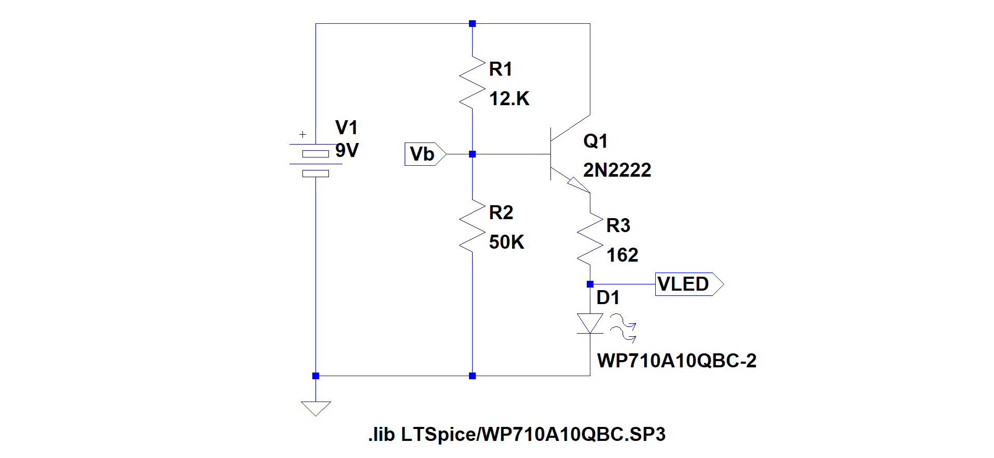

Figure 2 - Simple Photo-sensor Circuit in LTSpice

## Procedure

Perform the following steps to create the schematics shown in Figure 2.

1. Clone <https://github.com/League-EE/Level-1> on your desktop.
2. Open the “Photosensor” schematic from “Level-1/Lesson 7” folder.
   1. This will launch LTSpice for you and load the “Photosensor” schematic.
   2. The schematics has the battery symbol already placed for you.
3. Set the battery voltage by right clicking on the battery symbol and entering 9V for “DC Value[V]” in the window that opens. Click “OK”.
4. Next, place the resistors:
   1. Right click on the schematic area (away from any other symbol already placed) and select “Draft 🡪 Component”. (Alternatively, you can use the F2 shortcut key.)
   2. In the search window type “res”. Symbol res will be highlighted on the window below, and you can see the symbol for a resistor in the preview window on the left.  
        
      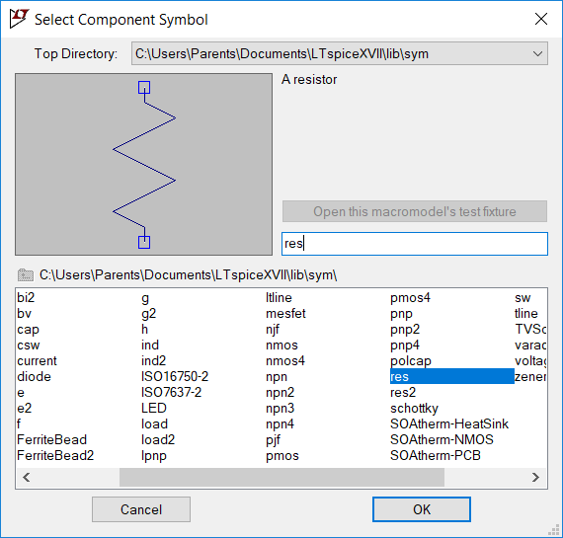
   3. Hit enter or click OK to select the res symbol.
   4. Place as many resistors as needed by clicking on where you’d like to place your resistors in the schematic area.
      1. Note that the component designator (R1, R2…) automatically increments as you place additional resistors on the schematic area.
   5. Once you have placed as many resistors as needed, hit “Esc” to dismiss the res component.
   6. If you accidentally place more resistors than needed, you can use the Delete tool (Scissors icon) from the Edit menu after right clicking on the open schematic area.
      1. Once the Delete tool is activated, you can click on a single component to delete that component, or you can click and drag to delete several components within the selection area.
5. Next, set the resistor values by right clicking on the individual resistor and following the steps below:
   1. From the “Edit Resistor R…” window that opens, click on “Pick a Standard percent value”.
   2. From “Select a resistor value” window that opens, select the value by scrolling and finding the desired value.
   3. Alternatively, you can right click on the value itself and type in any value in the “Enter a new Value for R…” window that opens.  
        
      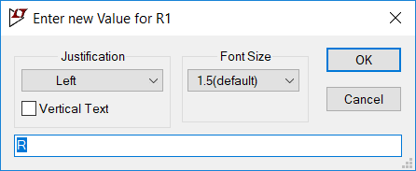
6. Next, place the symbol for a transistor:
   1. Press F2
   2. In the search window, type npn. (NPN is the type of transistor that we are using in this circuit.) You can see the symbol “npn” highlighted in the window below, and you can see the symbol for an NPN transistor shown in the preview window on the left.
   3. Click “OK”, and place one NPN transistor on the schematic. (Follow the general placement given in Figure 2.
   4. Hit “Esc” to dismiss the transistor placement tool.
7. Set the transistor model
   1. Right click on the transistor itself and click on “Pick new transistor” from the “Edit Bipolar Transistor Q…” window that opens.  
        
      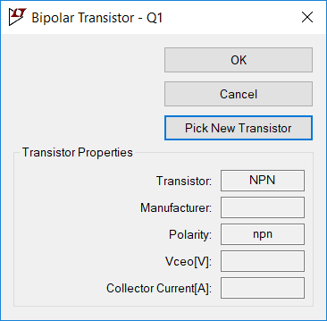
   2. From “Pick a transistor from the database” window, pick “Part No.” 2N2222 and click OK.  
        
      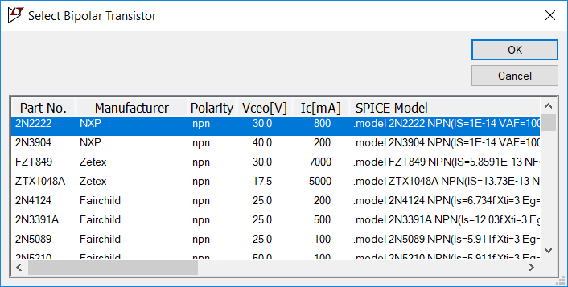
8. Place an LED on the schematic.
9. Set the LED model
   1. In order to set the correct model for the LEDs that was used in your circuits, you would need to tell LTSpice which model to use. (The model for this LED is not included in LTSpice’s standard library.)
   2. SPICE directives are used to tell LTSpice how to add a new library:
      1. Right click on any open space on the schematic area and select “Draft” 🡪 “SPICE Directive”.
      2. In the “Edit Text on the Schematic” window, type the following:  
           
         .lib LTSpice/WP710A10QBC.SP3  
           
         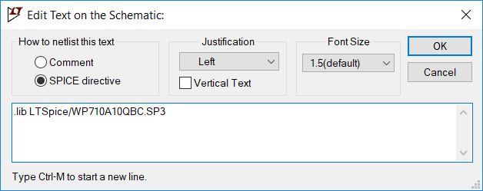
      3. Place the generated text on the schematic below your components.
      4. Right click on the LED model (“D”) and in the “Enter a new Value for D…”, enter WP710A10QBC-2. (This is the model name used in the library that we specified in the step ii above.) Click “OK”.
10. Connect all the components using the Wires tool
    1. Right click on an open space on the schematic area and select “Draft” 🡪 “Wires”. (Alternatively, you can use the F3 shortcut key.)
    2. The cursor changes to a crosshair. Place the cross hair on component pins that need to be connect and draw the wires.
11. Place a ground “Net Name”
    1. SPICE simulations do not work correctly without a “GND” net name. (All voltages in the circuit will be measured with respect to the net that is designated as ground, “GND”.)
    2. Right click on an open space on the schematic area and select “Draft” 🡪 “Net Name”. (Alternatively, you can use the F4 shortcut key.)
    3. From “Enter Net Name”, select “GND (global node 0)” and click “OK”.  
         
       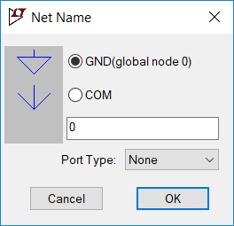
    4. Place the GND symbol close to the net connect LED D1 to the negative terminal of the Battery V1.
    5. Connect a wire from the GND terminal to the net connecting LED D1 to the negative terminal of the Battery V1.
12. Add additional net names to help with simulation waveform display later
    1. Right click on an open space on the schematic area and select “Draft” 🡪 “Net Name”. (Alternatively, you can use the F4 shortcut key.)
    2. In the “Net Name” Window, type Vb.
    3. Select “Input” for the “Port Type” and click “OK”.  
         
       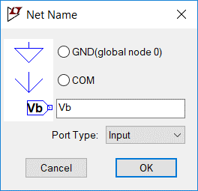
    4. Place the port symbol close to the net connecting R1 & R2.
    5. Connect the port with a wire to the net connecting R1 & R2.
    6. Using the same steps outlined above, create an output port named VLED and place it close to the net connecting R3 and D1.
    7. Connect VLED port with a wire to the net connecting R3 and D1.

Your schematics should now look like the drawing in Figure 2.

In order to run simulations, you have to tell SPICE what to do. This is done again using “SPICE directives:

1. Right click on an open space on the schematic area and select “Draft” 🡪 “SPICE directive”.
2. In the “Edit Text on the Schematic” window, type  
     
   .tran 0 1ms 1us startup  
     
   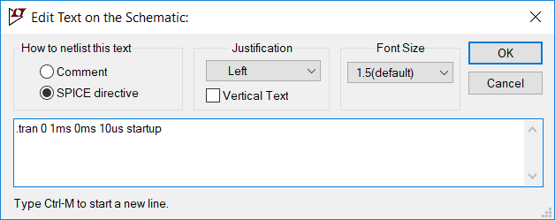  
   1. This directive is telling SPICE to run a transient (.tran) or time simulation where the starting time is 0, the stop time is 1ms and the time steps are 1us. It also tells SPICE to set the initial voltages to 0 (startup).
   2. Click “OK” and place the resulting text at the bottom of the schematic.
3. Now click on the “running man” icon on the top left corner of the schematic window. (Alternatively, you can right click on any open space in the schematic window and select “Run”.)
   1. This will run the simulations and opens the “Photosensor.raw” waveform window where the waveforms will be displayed. Note that the window will initially be empty (no waveforms).
4. Display the desired waveforms:
   1. Click on the “Add Trace(s)” icon (3rd from left on the top left corner of the window). (Alternatively, you can right click on the waveform window and select “Add Traces”.
   2. From “Compose Expressions to Plot” window, select V(vb), V(vled) and I(D1) to plot the voltages at Vb and VLED and the current through the LED D1. Click “OK”.
      1. Now you should be able to see the waveforms selected above in different colors.
5. Record the values of voltages and currents
   1. Click on V(vb) at the top of the window.
   2. From the window that opens for cursor 1, look up the “Vert” value. This is the voltage value. Record this value in the table below.
   3. Repeat these steps to record the values for V(vled) and I(D1) to record the voltage for VLED and current through LED D1. Record these values in the table below as well.

|  |  |  |  |
| --- | --- | --- | --- |
|  | **V(vb)** | **V(vled)** | **I(D1)** |
| **Value** |  |  |  |